

**Tribhuvan University**

**Institute of Engineering**

**Purwanchal Campus, Dharan**

**C-Programming Lab Report**

Prepared by:- Nigam Yadav

**LAB SHEET NO.4 [To be familiar with Unformatted and Formatted I/0]**

1. WAP to get your name, address and display using unformatted I/O.

**Code:**

#include<stdio.h>

int main()

{

int a[100],b[80];

printf("Enter your name:");

gets(a);

printf("Enter your address:");

gets(b);

printf("Your name is ");

puts(a);

printf("Your address is ");

puts(b);

return 0;

}

Output:



2. WAP to get a character from the user using unformatted I/O and display the ASCII value of the entered character.

**Code:**

#include<stdio.h>

int main()

{

char a;

printf("Enter a character:");

a= getchar();

printf("The entered character is ");

putchar(a);

printf("\nThe ASCII value is %d",a);

return 0;

}

Output:

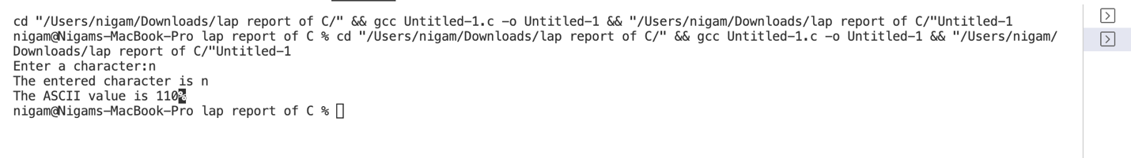

3. WAP to display the output as [take a=15, b=20.43, c=35]:

A= 15|15 | 15|15 | 15|15 | 15|15 | 15|15 |

B= 20.43|20.43| 20.43|20.43 | 20.43|20.43 | 20.43|20.43 | 20.43|20.43 |

C= 35|35 | 35|35 | 35|35 | 35|35 | 35|35 |

**Code:**

#include<stdio.h>

int main()

{

int a=15,c=35,A,B,C;

float b=20.43;

printf("A=%5d|%-5d|%5d|%-5d|%5d|%-5d|%5d|%-5d|%5d|%-5d|\n",a,a,a,a,a,a,a,a,a,a);

printf("B=%5.2f|%-5.2f|%5.2f|%-5.2f|%5.2f|%-5.2f|%5.2f|%-5.2f|%5.2f|%-5.2f|\n",b,b,b,b,b,b,b,b,b,b);

printf("C=%5d|%-5d|%5d|%-5d|%5d|%-5d|%5d|%-5d|%5d|%-5d|\n",c,c,c,c,c,c,c,c,c,c);

return 0;

}

Output:

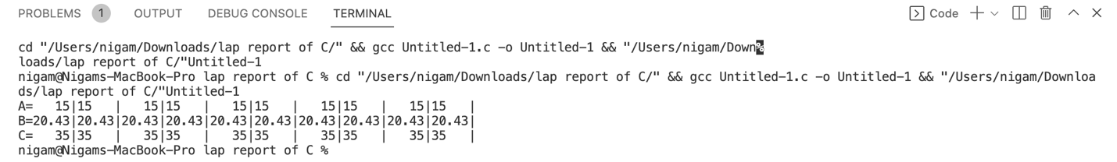

4. WAP to display the output as below using formatted I/O [take char a[] =”I Love Nepal”].

I

I L

I LO

I LOV

I LOVE

I LOVE N

I LOVE NE

I LOVE NEP

I LOVE NEPA

I LOVE NEPAL

**Code**:

#include <stdio.h>

int main()

{

char a[]="I LOVE NEPAL";

printf("%.s\n",a);

printf("%.3s\n",a);

printf("%.4s\n",a);

printf("%.5s\n",a);

printf("%.6s\n",a);

printf("%.7s\n",a);

printf("%.8s\n",a);

printf("%.9s\n",a);

printf("%.10s\n",a);

printf("%.11s\n",a);

printf("%.12s\n",a);

return 0;

}

